SAFETY ALERT
TBIT Bagroom
January 24 ,2020

This is a reminder to all, that in order to prevent flight delays and inconveniences, NO vehicle or equipment is allowed to park or block airlines operations on drive paths in the TBIT Bag Room (Interstitial level). All service providers are to attend to their respective operations in a timely manner as to not impede or obstruct the entry or exit paths in the TBIT Bagroom.
Example of Prohibited Items / Equipment:
- Tugs
- Dollies
- Cones & Chocks
- Containers & Pallets
- Baggage
- Carts
- FOD (Plastic wrap, Styrofoam, Wooden pallets)
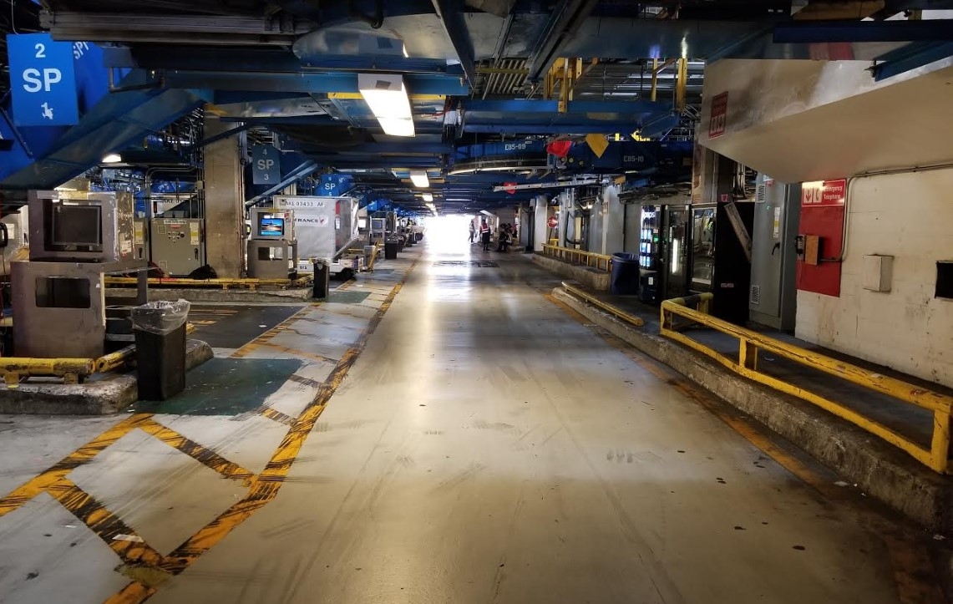
REFRENCE: LAWA Rules and Regulations
https://www.lawa.org/en/rules-and-regulations/lax-rules-and-regulations

- 11-1-1.b. not be operated in a careless or negligent manner or in a way that would endanger persons or property.
- 1.1.11. Stopping, Parking, and Unattended Vehicles/Equipment.

For any questions or concerns please contact the TBITEC Hotline (310) 646-9378.

