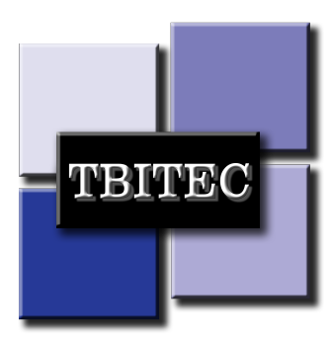
SAFETY ALERT
TBIT PBB Electrical Safety Procedures
June 28, 2019

TBIT electrical outlets located on the boarding bridges are NOT to be used for connecting any type of personal electronic devices. On June 28th,2019, during the maneuvering of the PBB, a mobile phone charger became entangled into the boarding bridge wheel drive chain. This incident placed the bridge out of service, which caused a disservice to hundreds of customers.

Vanderlande technicians were able to remove the entangled item, however please remind all personnel that electrical outlets on the passenger boarding bridges are NOT to be used for any personal use.
JUNE 28th INCIDENT:
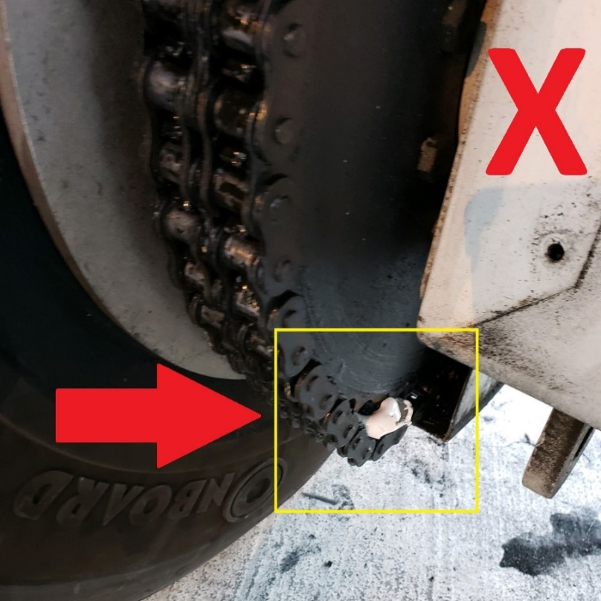
- Mobile phone charger inside the drive chain: 2. Phone charger removed from chain:

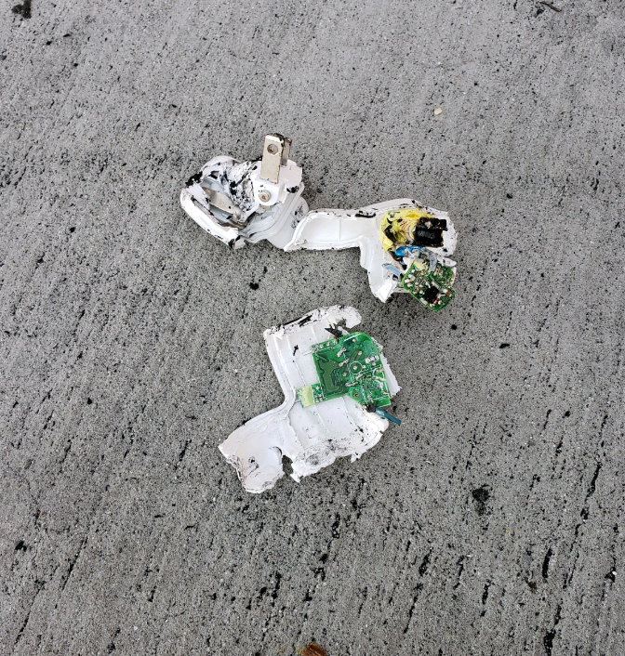

EXAMPLES OF PROHIBITED ACTIVITY:

- Mobile phone being charged in the restricted electrical receptacle.

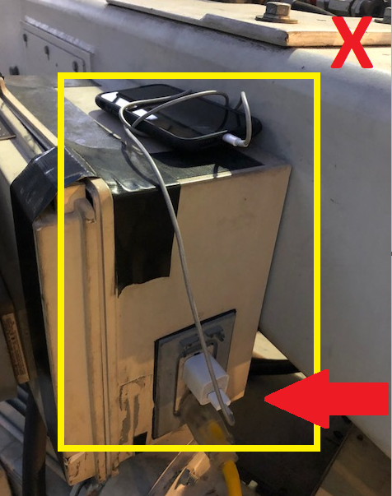

- Mobile phone and extension cord connected to the restricted electrical receptacle.

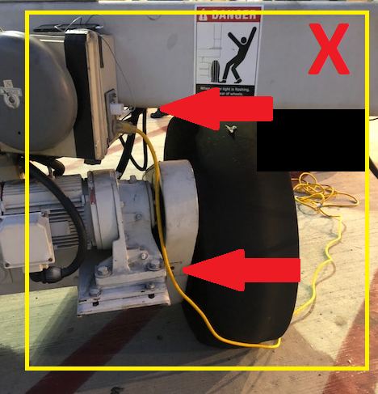

In the event of damage or inoperable equipment please contact below:
Vanderlande / Control Room: (310) 215-1218
TBITEC Hotline: (310) 646-9378

